

iCommand

Voice Command Based Mobile Phone

Intelligent Systems CS3612  
Project Final Report

Group Members

Kumarasinghe C.U.     100282N

Kumarasiri M.K.D.S.     100285C

Mannapperuma J.     100330L

Wijesinghe W.O.K.I.S.     100609C

Contents

Introduction 3

Purpose 3

Problem Statement 3

Background 3

Implementation Approach 3

Scope 3

Literature Review 4

Introduction 4

Body 4

Methodology 6

Tools Used 6

Libraries Used 6

Detecting Incoming Calls on Android Device 6

Creation of Parcelable Contact 7

Getting the Audio Input to the Speech Recognition Service 8

Processing of Commands 9

Get Suggested Contacts 10

Display Suggested Contacts on the Screen 11

Speech Recognition Service 12

Results 13

Conclusion 13

Member Contribution 14

References 14

# Introduction

This report is indented to give detailed information about the Intelligent System Project “Voice command based Mobile Phone” which we given a name for the application as “iCommand”. A detailed look at the algorithms used and alternatives to it are also discussed in the literature review. Implementation methodology, tools used and the final results of the project is also included in this report.

## Purpose

The purpose of this project is to put theory into practice by understand and developing an intelligent system which gives a solution to a common problem.

## Problem Statement

Develop a mobile application that can recognize voice commands such as “Answer”, “Busy”  “call some_name” and recognize names of users.

## Background

Many users of mobile phones face the difficulty of answering or rejecting a call while they are driving. With an application which is able to recognize words and names it is possible to answer calls send back sms messages to people without even touching the phone. This is a promising area and many applications have been developed by android and IOS developer in this area. Voice-Answer Lite on the android market is one example.

## Implementation Approach

As Android is the most popular mobile platform and as it is an open source operating system it was our choice for developing the application as most of the team had prior experience in developing android applications.

## Scope

We had scoped the project to recognizing names of people in the contact list and to call them or to reject a call when somebody is calling the phone.

# Literature Review

## Introduction

Speech recognition is “the process of enabling a computer to identify and respond to the sounds produced in human speech”, in other words translation of spoken words into text.

The process from human voice (speech) to be recognized by the mobile phone to calling a friend is not that complex.  First it is necessary recognize words/name spoken by a person. Next to find the word/name which matches the contact details of the person. Then to call that person using services provided by operating system.

There were two types of modeling that could have been used for speech recognition. Those are Acoustic modeling and Language Modeling. In Acoustic Modeling, it requires a model created by listening to audio clips of human speech comparing it with a the word transcript and using statistical analysis to process it and by the process of training it is possible to predict new combinations words but it cannot understand new words which are not in the grammar rule set.

Language Modeling also uses a set of grammar rules but it also tries to incorporate properties of language. Thus it has the ability to recognize words which are not in the defined set of grammar rules. Thus giving this technique the ability to predict new words. This is more of a probabilistic method which uses the likelihood model.

## Body

For the Natural Language Processing part we used the Naïve Bayes Classifier. This is a Machine learning algorithm. This involves acquiring model or data from experience.

Case 1:

(Resource)Input: Sound made from a person.

Classes: {hello, can, go..} words from a dictionary.

Goal: Identify or to predict input sound matches words from a given dictionary.

Case 2:

(Resource)Input: Name Spoken by a person.

Classes: {Sam, Dean, Samuel, ..}

Goal: Identify or to predict name match the list of contacts in the phone.

Rule based knowledge base is used to give base line for the algorithm to happen. For that a training set is created.

This training  set {(“sound of [hello]” ,hello),  (“sound of [can]”, can), …} guidelines(rules) for speech recognition.  The algorithm should be able to predict sound of a word by using this learning approach and if successful add the new recognized words into the training set. Here a person might have to read a certain passage in order for the algorithms to produce accurate pradictions.

The Naïve Bayes Classifier is based on Bayes Rule. When Bayes rule is applied for a **Resource r** and a **class c** as decribed above in the example

$$P\left(c | r\right)= \frac{P\left(r | c\right)P(c)}{P(r)}$$

Conditional Probability that a given resource **r** is the **c** word in the class C. By picking the highest conditional probability it is possible to guess which word the user has spoken. This can be seen in the following equation.

$$c_{MAP}={argmax}_{c∈C}P\left(c | r\right)$$

$$c_{MAP}={argmax}_{c∈C}\frac{P\left(r | c\right)P(c)}{P(r)}$$

But P(r) is constant for all objects in the class C

$$c_{MAP}={argmax}_{c∈C}P\left(r | c\right)P(c)$$

MAP is the Maximum A posteriori Probability estimate which is similar to Fishers Maximum Likelyhood (ML).

Then couple of assumptions is taken into consideration, these are called **Multinomial Naïve Bayes Independence Assumptions**.

1. Bag of words assumption: The position of words doesn’t matter.
2. Conditional Independence: Assume that feature probabilities are independent given a class c.

Thus,

$$P\left(x_{1} {,x}_{2 }{,…x}_{n} | c\right)=P\left(x_{1} | c\right)*P\left(x_{2} | c\right)*P\left(x_{3} | c\right)*..*P\left(x_{n} | c\right)$$

Then by simply calculating cNB value for each object in class c with respect to resource r by the equation we can find the best possible guess for the resource in this case the audio sound to word mapping,

$$c_{NB}={argmax}_{c_{j}∈C}P\left(c_{j}\right)*\prod_{i∈positions}{P\left(x_{i} | c_{j}\right)}$$

This equation is true for any number of classes.

# Methodology

## Tools Used

1. Android Developer Tools Bundle[2]

The Android ADT bundle includes the following tools,

* Eclipse + ADT plugin : Used for project creating and deployement
* Android SDK Tools : To create an android application on eclipse
* The latest Android system image for the emulator : To virtualize the application on an android device

1. GitHub and Git[1]

Project Source code management and project integration.

## Libraries Used

1. Great Android Sensing Toolkit (GAST)[3]

Provides templates and algorithms for sensing tools in an android device.

1. Android API Services[4]

Phone state & User input were taken by this library.

1. Android API Speech Package[5]

Speech Listening Service was implemented by this library.

## Detecting Incoming Calls on Android Device

To detect whether the phone is ringing we use the **Telephone Manager** class and it’s method **listen.** This requires the android permission of **READ_PHONE_STATE.** By extending this class and overriding the method **onCallStateChanged** it is possible to detect the phone state and the incoming call number. The phone state can either be one of **RINGING**, **OFFHOOK** or **IDLE**.

## Creation of Parcelable Contact

It is important to create a **Parcel** of the contact information which are the display name and the phone number as it used as a object to send information through. Thus the creation of **Contact** object which uses the **Parcelable Interface** was necessary.



## Getting the Audio Input to the Speech Recognition Service

When receiving audio stream it is then processed by the Speech Recognition Service.





## Processing of Commands

The strings of matching names are checked with the name list until a match is found. If a match is found and there are names in the list then it will show the suggested contact info on the screen.



## Get Suggested Contacts

By iterating through the name list with the android contact name list it is possible to find which contact the name belongs to.



## Display Suggested Contacts on the Screen

By using an android alert dialog it is possible for the user to view the suggested contacts on the screen.



## Speech Recognition Service





# 

# Results

We were able to create an application that will ask the user speak or to run the service in the background. From this service the user is able to answer a call or to reject an incoming call by replying to the phone when it rings. The user can change these setting in the application interface.

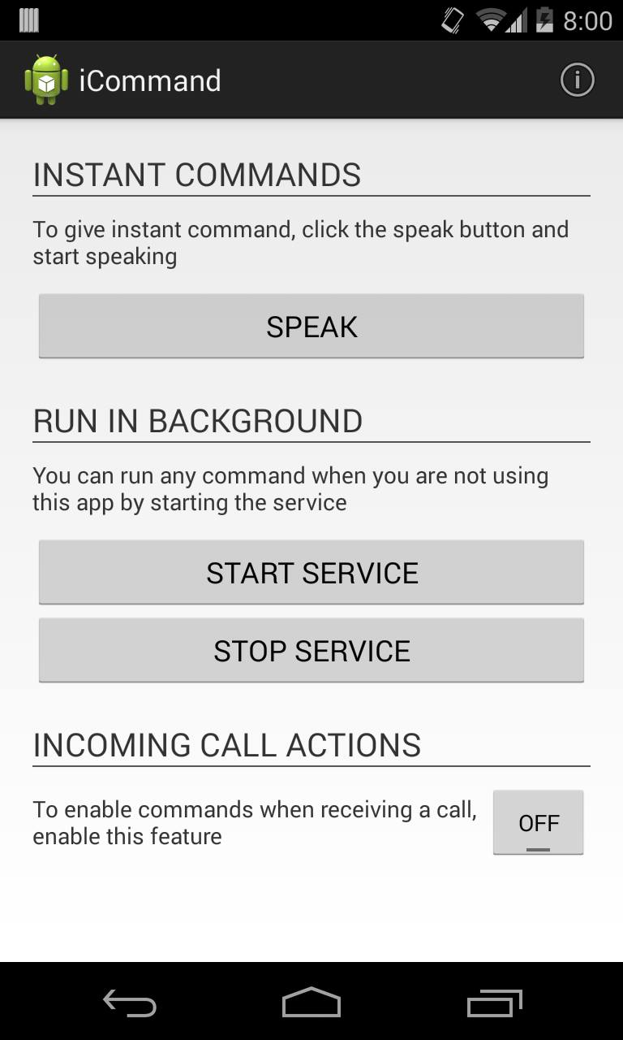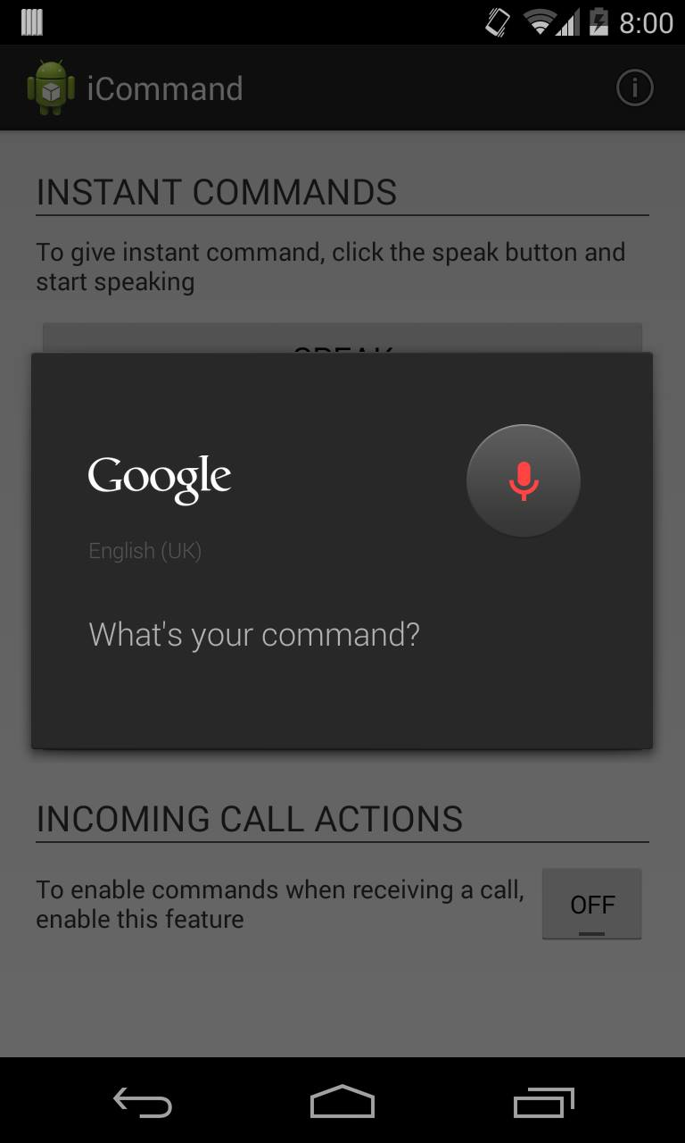

# Conclusion

In conclusion the project was successful in that we managed to create a working application that completes the problem statement. The naïve base classifier is more suited for text processing but it is successfully possible to incorporate into voice recognition as well.

# Member Contribution

|  |  |  |
| --- | --- | --- |
| Member Name | Index Number | Contribution |
| Kumarasinghe C.U. | 100282N | Project Report  Literature Review |
| Kumarisiri M.K.D.S. | 100285C | Implementing background service to get user commands (eg. Call Someone) |
| Mannapperuma J. | 100330L | Implementing Instant Commands (eg: Call Someone, Close)  Component Integration |
| Wijesinghe W.O.K.I.S | 100609C | Implementing Reject & Answer  commands when receiving a call |

# References

[1]. iCommand, Project Repository for *Voice Command Based Mobile Phone*. Available: https://github.com/mj7007/iCommand.

[2]. Android SDK Bundle. Available: https://developer.android.com/sdk/index.html.

[3]. Great Android Sensing Toolkit (GAST). Available: https://github.com/gast-lib/gast-lib.

[4]. Android API Services. Available: http://developer.android.com/guide/components/services.html

[5]. Android API Speech Package. Available: http://developer.android.com/reference/android/speech/package-summary.html

[6]. Detecting incoming and outgoing phone calls on Android[Blog]. Andrey Moskvichev. Available: http://bitgriff.blogspot.com/2013/01/detecting-incoming-and-outgoing-phone.html